Part of: Aggregate Functions:To perform aggregation operations on the E-Commerce database using SQL aggregate functions.

Sub-Task A: Calculate Total Value of All Products
- SQL Query:
SELECT SUM(price) AS total_product_value FROM products;

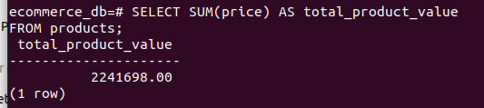
- Explanation:-
This query calculates the total value of all products by summing the price column from the products table using the SUM() function.

Sub-Task B: Count Total Number of Orders

SQL Query:
SELECT COUNT(*) AS total_orders FROM orders;
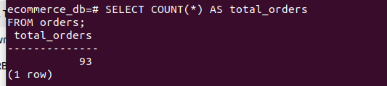

- Explanation:
This query counts the total number of orders present in the orders table using the COUNT() function.

Find the Highest Product Price
- SELECT MAX(price) AS highest_price FROM products;
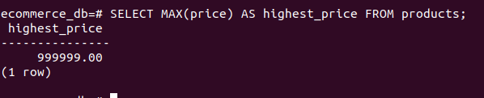
- Explanation:
This query uses the MAX() function to find the highest price among all products in the products table. It helps identify the most expensive product in the E-Commerce system.

Find the Lowest Product Price

- SELECT MIN(price) AS lowest_price FROM products;
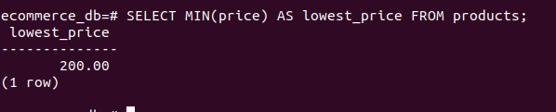
- Explanation:
This query uses the MIN() function to retrieve the lowest price from the products table. It is useful for finding the cheapest product available

Calculate the Average Product Price

- SELECT AVG(price) AS avg_price FROM products;
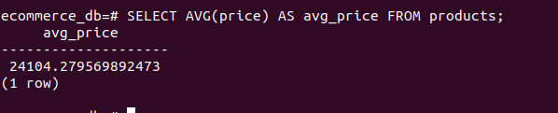
- Explanation:
This query uses the AVG() function to calculate the average price of all products in the products table. It provides an overall pricing insight of products in the E-Commerce database.

